BTI225 - Assignment 5: HTML Form, CSS, JS validation (50 marks)

# Due date

Friday, April 9, 2021 - 11:59pm

Grade value: 6% of your final course grade

Objective

You are asked to create an imaginary online store. Your site will focus on the HTML, CSS, and JavaScript.

What will your store sell? In the past students have focused on clothing, jewelry, second-hand clothing, make-up, cakes, tea, and computers. Your store can sell whatever you want, and you can use this as a way to say something about your personality and interests. It can be fun, funny, or serious. Ideally, you'll build something in this assignment that you'll be proud to show in interviews when applying for co-op positions. Former students have used their stores to showcase their web development skills and get hired.

Pages Layout

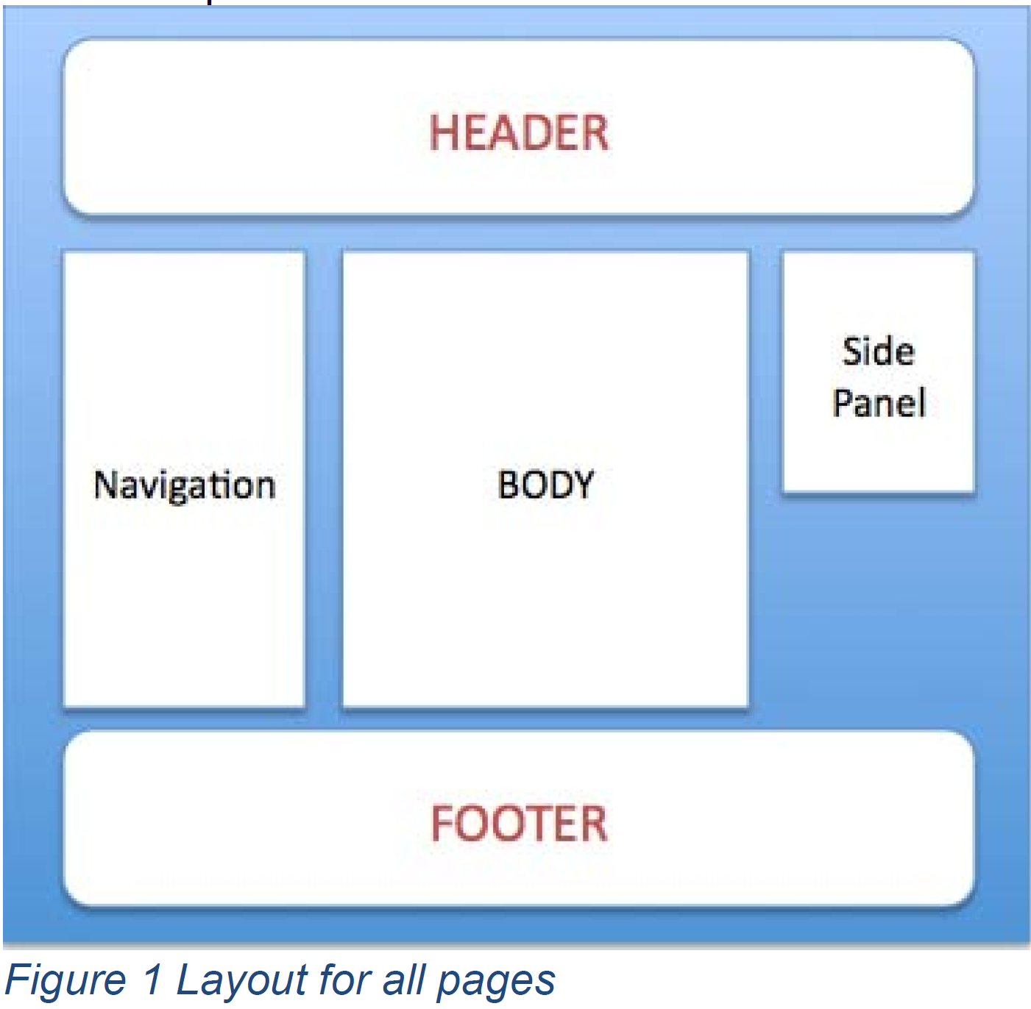

The specific height and width of each panel is for you to define; the provided figure is abstract schematics meant to illustrate the general layout of the pages. Your page, however, should have the following formatting: all panels should have a border; the page should have a background of some color; the text of the header and footer should be in a different color than the rest of the panels. The side panel is optional depending on your design/requirement (mandatory for info page). Ideally there should not be any horizontal scrolling. The navigation must have links to all other pages with the currently visited page as active link. The header should contain a logo and name of your choice.

Pages Minimum Requirements

1. Home Page: Should include general information about your store. Make it as friendly as possible because that would be the first page a costumer would see.
2. Products Page: Will include a list of items your store is selling. Each item should have a picture and price associated.
3. Info Page: A contact form in which a user can fill his/her information. This page should allow a user to fill out his/her information such as first name, last name, password etc. The page must have password field appearing twice: to confirm password match. In addition, this html page will have a submit button, a reset button and must support JavaScript validation. The validation requirement is provided below:
   1. You must make all fields mandatory to insert for users.
   2. First name: Must start with a cap and only alphabet allowed.
   3. Last name: Must start with a cap and only alphabet allowed.
   4. Password: must be 6 characters long, must start with a character, must have at least 1 digit and 1 uppercase. The password strings must match. Pattern attribute is not allowed for this field. -> **“/^(?=.*[a-z])(?=.*[A-Z])(?=.*\d)(?=.*[@$!%*?&#])[A-Za-z\d@$!%*?&#]{6,}$/”**
   5. Username: username must start with a letter, must have at least 6 characters. Pattern attribute is not allowed for this field. -> **^[A-Za-z][A-Za-z\d@$!%*?&#]{6,}$**
   6. Address: Text Field. Must be filled.
   7. Province: Dropdown list: select and option elements, required.
   8. Gender: Type of radio. The value must choose from one of the following: Male, Female, Prefer not to share.
   9. Email: use html5 input type for default validation.
   10. Age: must be in between 18-60.
   11. The name of the form must be “signup” to accept user’s input for creating user account. This form must submit to https://httpbin.org/post using the post method only when the form does not contain any validation errors. You have two options for displaying error messages-
       1. Display appropriate messages in side panel only for each error when the user clicks the submit button. OR
       2. Your code should validate the field immediately after it has been changed (if applicable) (hint: use the onchange or onfocusout etc. event handler to call JavaScript functions). Show only one error for a field, at a time. Appropriate messages must be shown for the invalid field in side panel only.
   12. You should use pattern matching wherever possible to make JavaScript code efficient. You may want to use “required" attribute as necessary. If there is no error found, then a success alert is displayed and form is submitted to https://httpbin.org/post.
   13. This page must have two hidden fields: one with your last name as value and lastName as field name/id and the other with your Seneca student id as value and studentId as field name/id. Failure to have this hidden field with appropriate property/value will result in zero mark for this page. Example is given below:

<input type="hidden" name="lastName" id="lastName" value="Your last name goes here" />

<input type="hidden" name="studentId" id="studentId" value="Your student Id goes here" />

1. Honesty Page: You must understand and add the following content with your full name in the body section.

“I declare that my assignment is wholly my own work in accordance with Seneca Academic Policy. No part of this assignment has been copied manually or electronically from any other source (including web sites) except for the information supplied by the BTI225 instructor and / or made available in this assignment for my use. I also declare that no part of this assignment has been distributed to other students.

Name: Type your name here

Dated: Type the submission date here “

CSS and JavaScript Requirements

You must have external css file called normalize.css that you will apply to html pages for presentation/layout. You will be evaluated based on creativity. You must have separate script files as necessary. All css and script must go into the external css and Js file.

Other Requirements

* You need to create a demo video in which you show the functionalities of your website. The video should be 5-7 minutes in length and it should demo all pages of the website but should concentrate on testing all the requirements of the form page.
* Your code will be evaluated for correctness of syntax and appropriate usage.

• Each HTML page must pass the W3C's HTML Validation: https://validator.w3.org/

• All CSS used in the assignment must pass the W3C CSS Validation: https://jigsaw.w3.org/css-validator

• All JavaScript code must not contain any run-time errors/exceptions.

* Late Penalty: 20% penalty each day for up to 5 days. After that, no submission will be accepted.

Submission

## Submit both your video and your zipped assignment5 to Blackboard under assignment section